Task 1: Inquiring and Exploring - CPU vs. GPU (THINK-PAIR-SHARE)
(Goal: Understand the differences between CPU and GPU architectures, as required for 1.1.3 HL only)
Level | Task Question
Level 1 | What are the main differences between the design philosophies and usage of a CPU and a GPU?
Level 2 | Explain how the core architecture and processing philosophy differ between CPUs and GPUs.
Level 3 | Explain how CPUs and GPUs collaborate in task division, data sharing, and execution coordination?

Rubrics

Criteria | 1–2 (Limited) | 3–4 (Basic) | 5–6 (Proficient) | 7–8 (Advanced)
L1: Design Philosophy | Gives a vague or incorrect difference. | States CPU = sequential, GPU = parallel (briefly). | Clearly explains sequential vs. parallel design and purpose. | Gives deep insight into latency vs. throughput design principles.
L2: Architecture & Memory | Mentions core count only; misunderstandings. | Identifies CPU = few big cores, GPU = many small cores; mentions RAM/VRAM. | Clearly explains cores, ALUs, memory bandwidth, and performance impact. | Gives detailed architectural comparison, including memory hierarchy and efficiency.
L3: Collaboration | Suggests GPU replaces CPU or gives no collaboration info. | States CPU controls the GPU. | Explains correct division of labor and data sharing (e.g., PCIe). | Provides detailed explanation of how CPU prepares tasks and manages GPU communication.

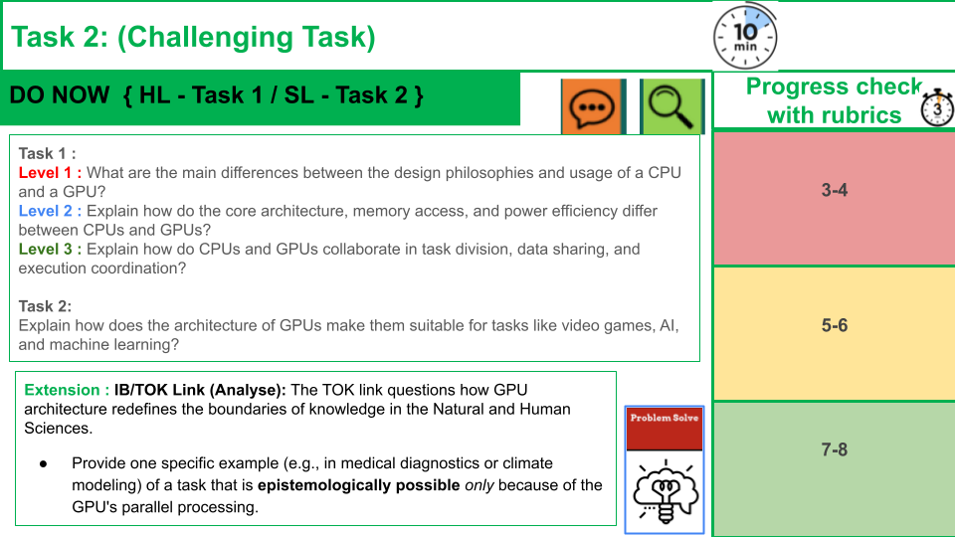
Rubrics

Level | What You Need to Show
1–2 | Very simple or unclear differences; missing key ideas.
3–4 | Basic explanations of CPU vs GPU, architecture, and how they work together.
5–6 | Clear and correct comparisons with good detail and examples.
7–8 | Detailed, accurate explanations with strong understanding of design, architecture, memory, and collaboration.

Level | What You Need to Show
1–2 | Gives a simple or unclear reason why GPUs are used in games/AI.
3–4 | Basic explanation: GPUs do parallel work or have many cores.
5–6 | Good explanation of how GPU architecture helps with graphics, AI, and ML tasks.
7–8 | Detailed explanation showing how parallel cores, high bandwidth, and specialized units (e.g., tensor cores) make GPUs ideal for these tasks.

Plenary :

Exit Ticket

Task | Success Criteria Statement | Check
1 | Identify the two primary architectural components that define the GPU (cores and memory).
2 | Explain the difference in processing philosophy between a CPU (sequential) and a GPU (parallel).
3 | Describe the GPU's original and modern roles in computing (graphics and GPGPU).
4 | Provide real-world examples of how the GPU is used in everyday technology (AI, video, etc.).

